

**Group Meeting #5**

The meeting of TeamSix has decided at Discord at 4th April 2021.

**Attend present**

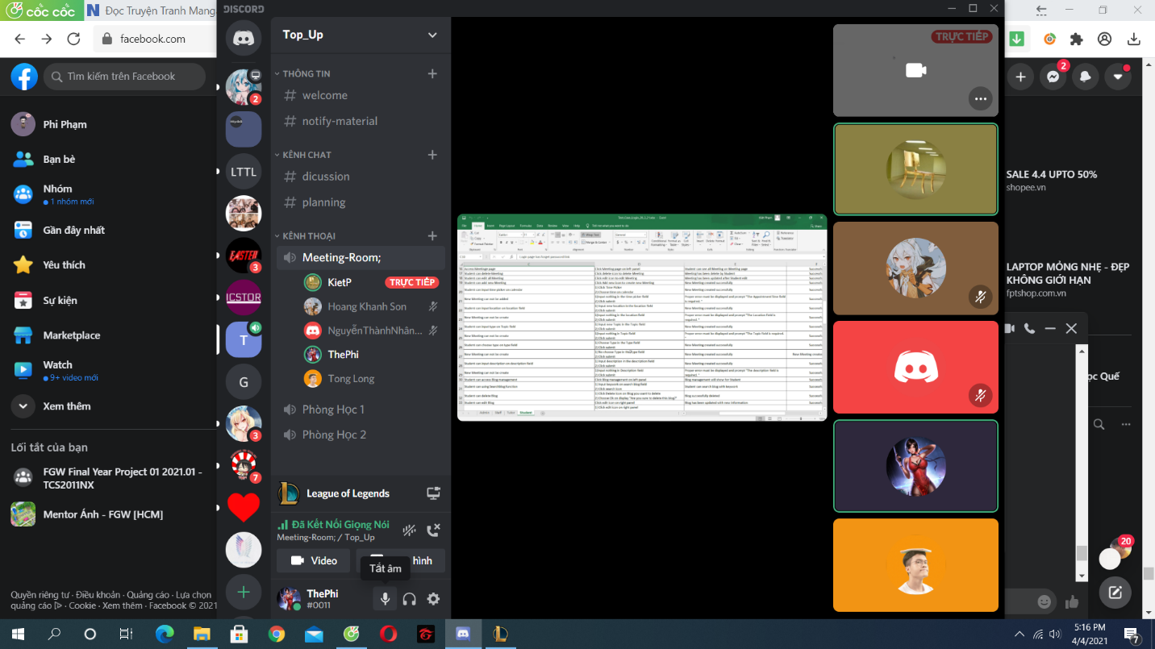

**There is 6 members in meeting:**

Pham The Phi

Hoang Khanh Son

Nguyen Hoang Nhan

Tong Dam Thang Long

Pham Tuan Kiet

**Member Not Attendance**

Trinh Huynh Duc

**Report about**

**Discuss about Marketing Coordinator’s function, test function and design layout.**

**Time Meeting**

An initial team discussion about the project was held on 4th April, 2021 at 17h00.

**Approve comments during the meeting**

Difficulty in perfecting previous functions.

**Unfinished Work**

Marketing Coordinator interface with student

**Next Work**

Work will hold at the next meeting at 10th April 2021.

**Work progress**

Slow